# Lab 4: CSS Flex - Grid

1. Open the provided starting code. The given HTML displays commercial information about books. For each book, a picture, title, author and a buy button are included. Every group is in an article with a “card” class.
2. Apply the flex layout approach to each article to display the elements vertically. Add every style necessary to obtain a result that is similar to the following example:

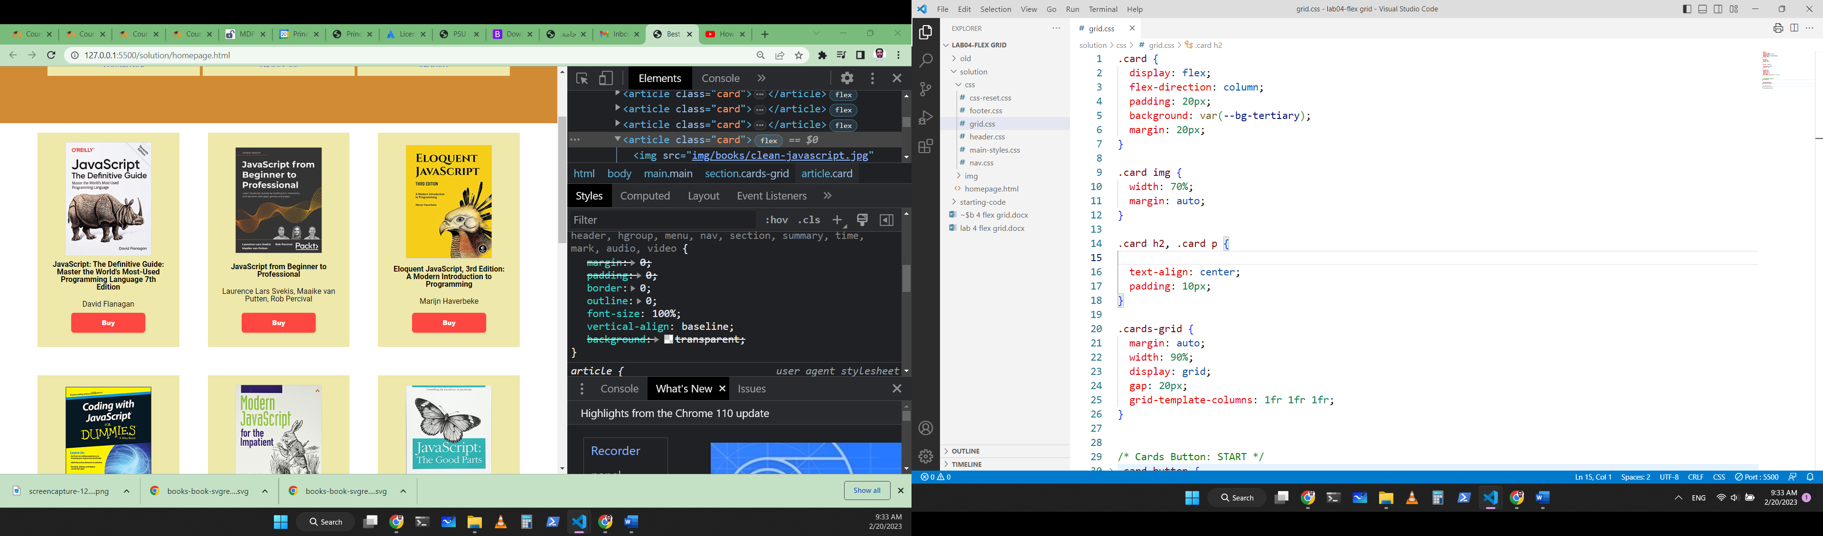

Fig. Example of one book flex box.

1. Include all the articles in a section element. Then, apply the grid approach to organize the product cards in a grid that displays:
   1. at most three books per row for screen wider than 980px,
   2. two columns for screens wider than 680px
   3. and one column if the screen is smaller.

Here is an example of the expected result:

|  |  |
| --- | --- |
|  | 1. Use flex boxes to adjust the header, nav and the footer of the page. |